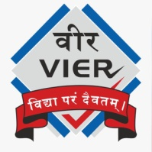 |  | Vadodara Institute  Details of Industrial Visit
 | Name of Industry / Organization |  | Param Technology
 | Address of Industry/Organization |  | 7th Floor, 707-710, Everest Onyx, Near Natubhai Circle.
 | Date & Day of Industrial Visit |  | 17/02/2026, Tuesday
 | Timing of Industrial Visit |  | 1 day
 | Semester |  | 4th,6th
 | Discipline |  | Computer/IT
 | Academic Year |  | 2025-26
 | Nos. of Students Present |  | Students (35)  Faculty (1)  Total (36)
 | Names of Faculties accompanied to students |  | Prof. Naman Shah
 | How this visit was useful to students for strengthening their practical understanding? |  | Students of Semester 4 and 6 visited Param Technologies for an industrial visit to gain insights into the IT industry. Experts Dipesh Majithia and Nisha Gor shared valuable guidance on current market trends and career-building strategies. They highlighted rapid advancements in artificial intelligence, cloud technologies, full-stack development, and cybersecurity, urging students to stay updated with these domains.. The visit effectively bridged the gap between academic learning and industry expectations, motivating students to set clear career goals and develop the skills needed to succeed in the competitive IT sector.
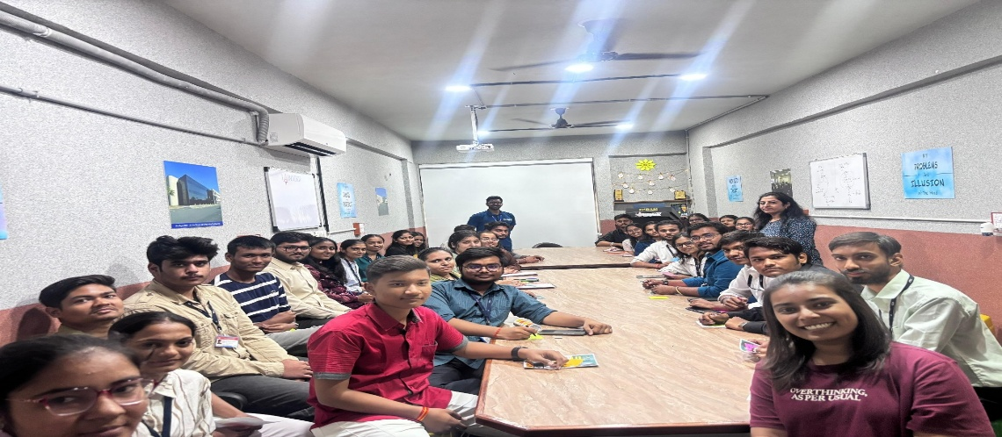

Prof. Naman Shah Dr. Jayeshkumar S. Patel
Faculty coordinator Principal

